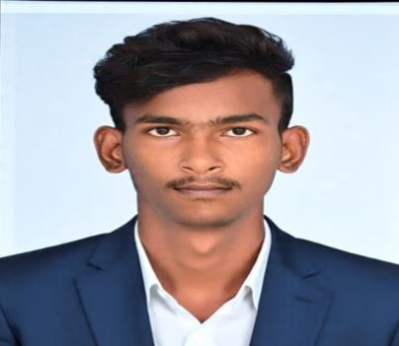
VISVA K
3/643,Pudunagaram,Enmanamkondan, Uchipuli,Ramanathapuram-623534.
E-mail: vvisva6374@gmail.com
Ph. No: 6374120196

OBJECTIVE
Seeking a position in the Automotive/Manufacturing industry where I can apply my understanding of mechanical systems, materials, and production techniques to support product development and process improvement.

EDUCATION
Degree /Course University / Board Percentae/CGPA Year of passing

Mechanical Engineering BE

HSC
Sethu Institute Of Technology
8.1% 2026

SSLC
Government Higher Secondary School | 64.3% | 2022
Raja Matric Higher Secondary School | 87.2% | 2020

AWARDS AND ACHIEVEMENTS
- Successfully completed NPTEL on INDUSTRIAL HYDRAULICS and AUTOMATION.

TECHNICAL SKILLS

- Material Handling.
- AutoCAD, SolidWorks Designing & Modelling, Manufacturing.

SOFT SKILLS

- Communication Skills
- Time Management
- Problem – Solving Abilities
- Organizational Skills
- Leadership

PROJECTS COMPLETED in MOVABLEHEADLIGHTS

The design,development, and fabrication of the movable headlight mechanism demonstrate a strong Commitment to engineering and automation.

The project involved comprehensive research on kinematics, force distribution, matrial selection, and Actuation mechanisms, ensuring optimal performance and realiability.

INTERNSHIPS
Interned as a CNC Lathe Programmer and Operator at A.D ENGINEERING SOLUTION, Coimbatore, where I gained hands-on experience in programming, operating, and maintaining CNC lathes, interpreting technical drawings, and optimizing machining processes.

AREA OFINTEREST
- Quality control and Maintenance
- Project Management and Operation
- Computer -Aided Manufacturing

DECLARATION
I hereby declare that the information provided above is true and correct to the best of my Knowledge and belief.

